Assignment - 2
- Change the Salesforce logo.
Step 1: Click on this “”


Step 2: Search Document, scroll down in All tabs
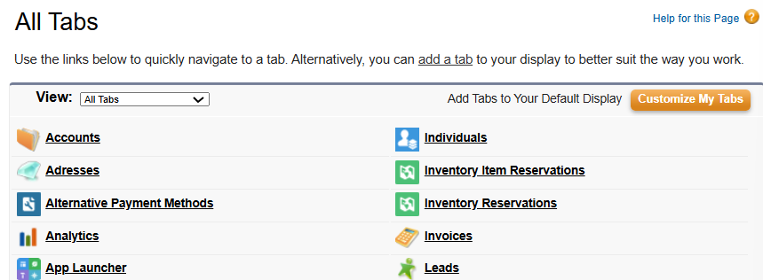
See document-

Step 4
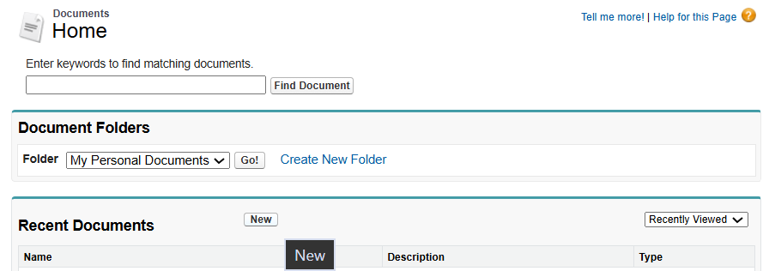
Step 5: Upload the image, and tick on the option “Externally available image”
Click on “Save”.
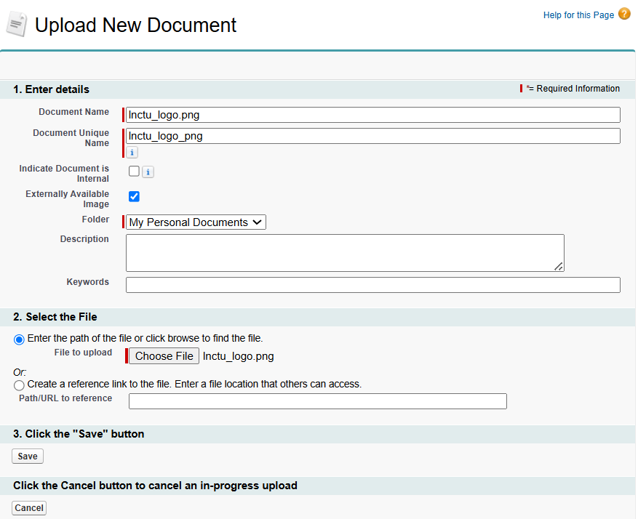
Result-
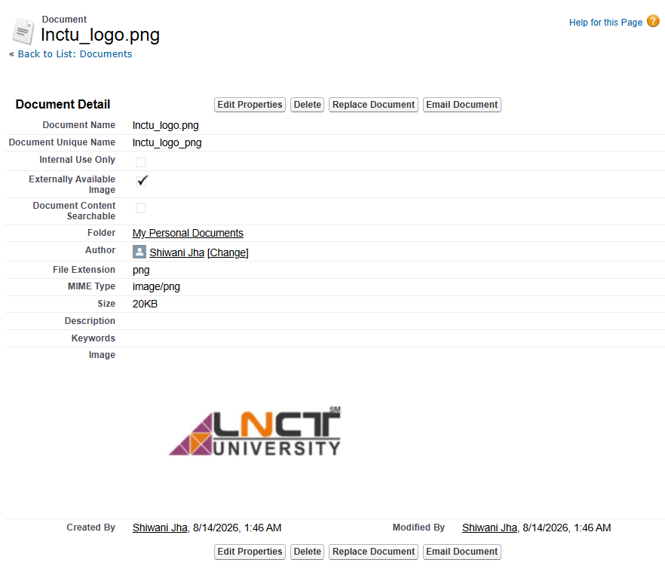
Step 6: click on setup
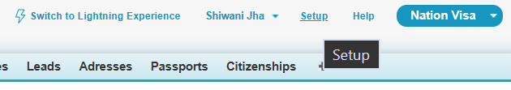
Step 7: Search apps
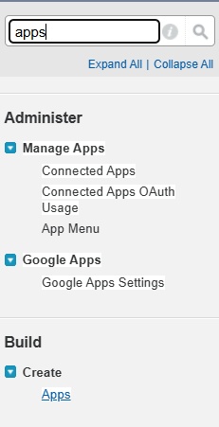
Step 8: Click on “Edit” of Nation Visa
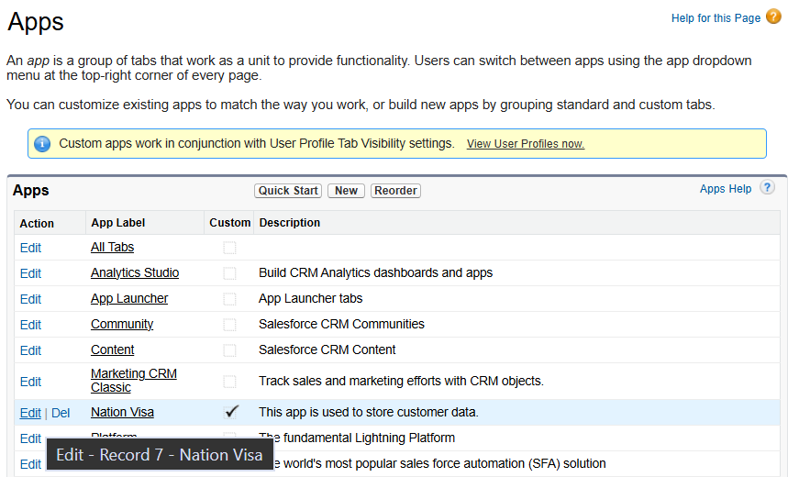
Step 9: Click on “insert image”
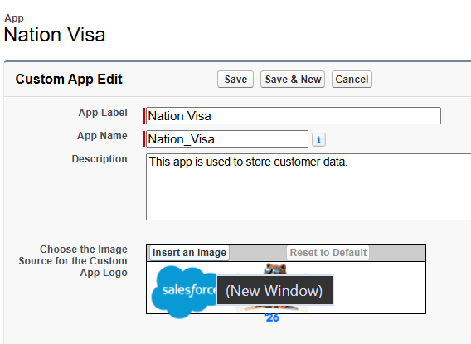
Step 10: Choose the image
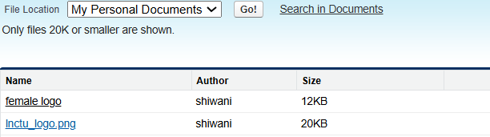
Step 11: Save it
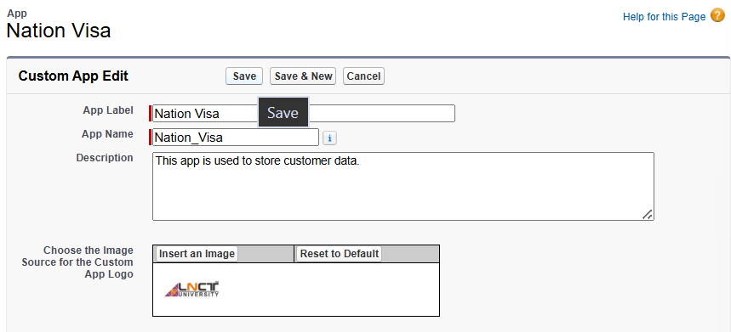
Result-
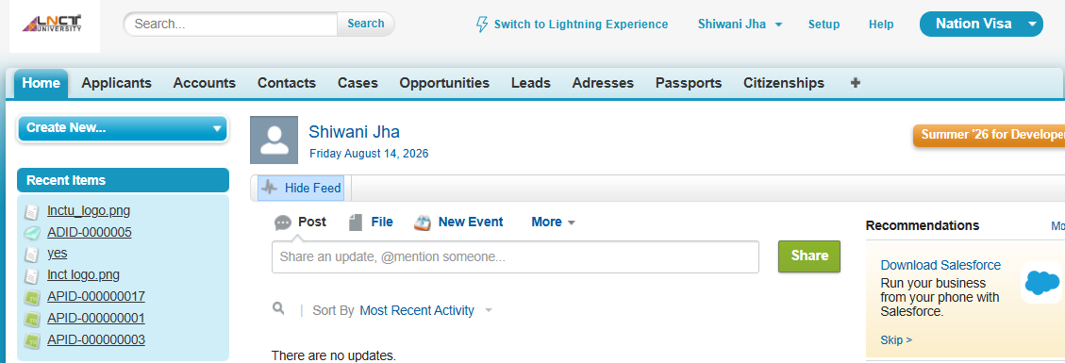
2. Change the Logo During Loading/Reload
Step 1: Go to -> Setup
Step 2: In Quick Find, search: Branding
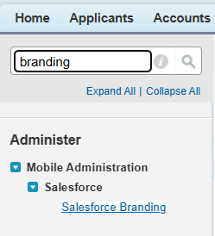
Then select: Salesforce Branding
Step 3: Click -> Edit
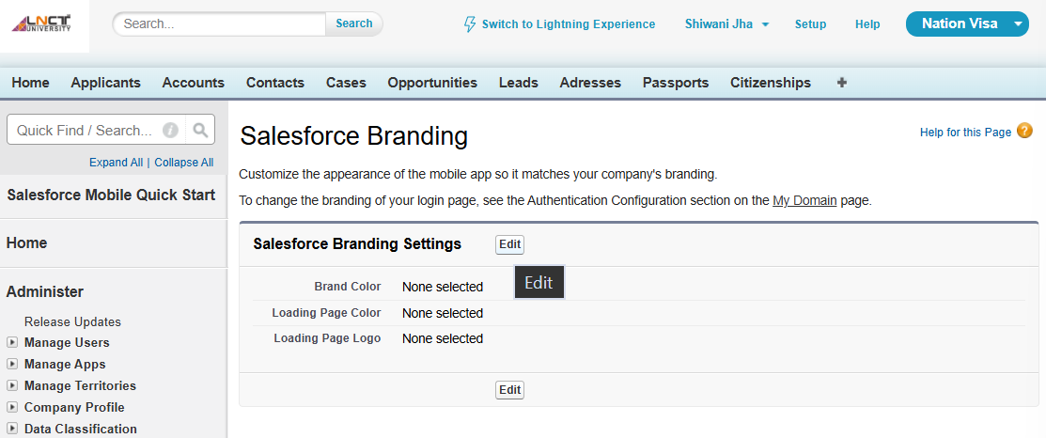
Step 4: Find: Loading Page Logo
Click: Choose File
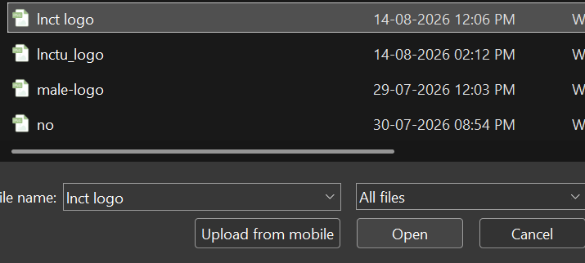

Step 5
Select your image from your computer.
For this loading-page logo, Salesforce currently accepts JPG, GIF, or PNG, up to 200 KB, with a maximum image size of 460 × 560 px.
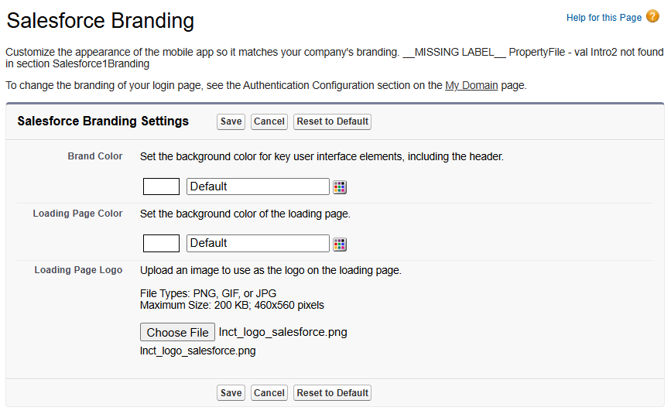
Step 6: Click: Save
Step 7: Now refresh/reload Salesforce and check the loading screen.

